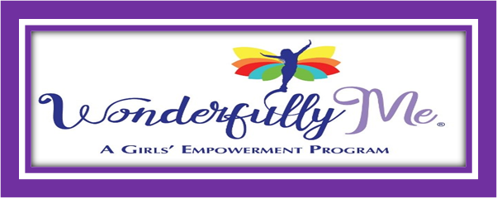

Volunteer Waiver, Release, and Hold Harmless Agreement

**PLEASE READ CAREFULLY. THIS IS A LEGAL DOCUMENT THAT AFFECTS YOUR LEGAL RIGHTS.**

I have agreed to serve as a volunteer with Wonderfully Me, Incorporated®. This agreement must be signed before you begin any activities with the organization. This includes your duties and all activities that Wonderfully Me Incorporated® conducts but is not limited to the Empowerment and Mentor components, fundraising and transportation.

I understand and recognize that my participation as a volunteer is a privilege.

I fully understand and agree to waive and assume all risks whether suits, claims, damages, costs involved in any and all duties that I perform as a volunteer on behalf of or in connection with Wonderfully Me Incorporated®.

I agree to hold Wonderfully Me Incorporated® harmless for any illness, injury(s), or death that I may sustain during my volunteer duties whether caused wholly or in part by simple negligence, fault or other misconduct from representatives of Wonderfully Me, Incorporated®.

This waiver does include myself, all my family members, and descendants forever from seeking any legal action against Wonderfully Me, Incorporated® or its successor organizations or any representatives thereof.

I acknowledge that I am fully aware of all risks posed by my volunteer activities and that I have no medical condition that prevents me from engaging in them.

By signing below, I have read, understood and agree to the assumption of risk, waiver, release, hold harmless and indemnification terms set forth above.

____________________________________________________________

Signature of Volunteer/Date

____________________________________________________________

If a minor, Signature of Parent or Legal Guardian/Date